INF250 Assignment 3 – Vegetation Mapping

Loading the image
Loading the image was very straight forward and similar what I have done before.

Function determining band numbers
To use this function, I first had to fetch out the wavelengths from the header-file. Then the function I implemented computes the nearest band number from the wavelengths list from the header file against the target wavelenghts. Lastly it outputs a dictionary as {‘color’ : bandnumber}.

Display RGD image from the hyperspectral image
To display the hyperspectral image, I used the Spectral Python method imshow. This was very straight forward.

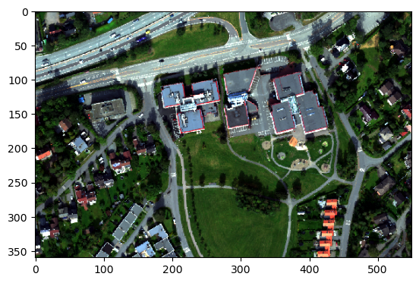

Function that computes NDVI + display of NDVI image
I can clearly see that vegetated areas stand out in the green-blue range of the image. The areas that are bulidings or roads stand out in the yellow-red range if the image.
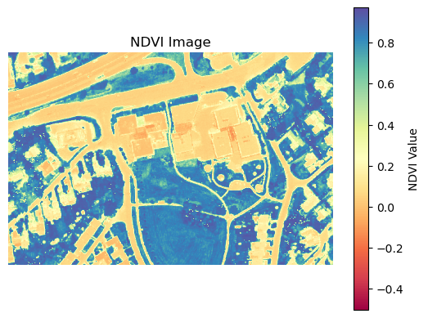

Spectra of different points
In the lectures, Ingunn howered over the images with aa crosshair to get coordinates for the points. I did not manage to use such crosshair. Therefore, the point coordinates in the code are approximations I have made. However, looking at the resulting spectral plot for the points, the “vegetation”-point is clearly vegetation based on the higher reflectance.

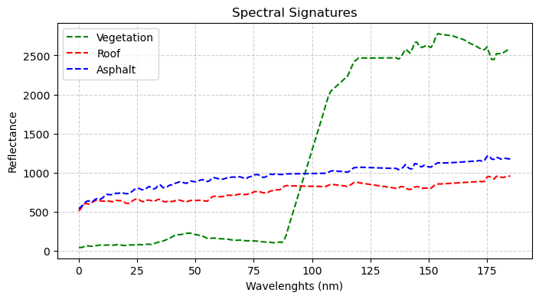

NDVI histogram
The histogram has two distinct peaks. The peak around zero corresponds areas in the image that are non-vegetated or poorly vegetated, while the peak from 0.6 to 1.0 corresponds to areas in the image that are vegetated.
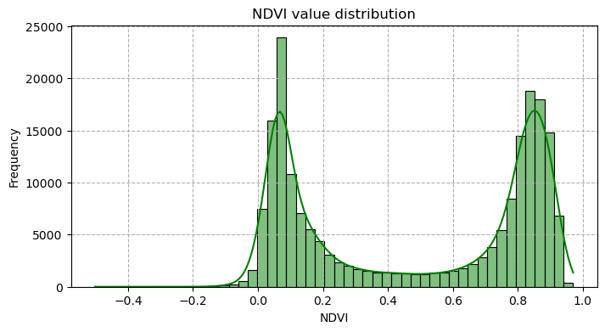

Thresholded NDVI
After applying a NDVI threshold the NDVI image changed remarkable. Now, the areas that in the original NDVIM image were dominanted by obvious vegetation is “excluded”, making the analysis more detailed. That is, less vegetated and non-vegetated areas stand out more in the image.
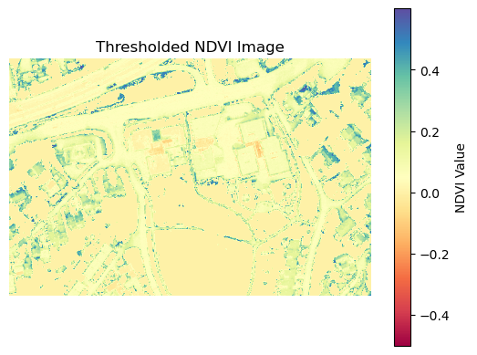

It is absolutetly popssible to determine the fraction of the image that has vegetation. To do this, first you must count the number of pixels that have vegetation, and then divide it by the number of pixels in the image. To count the number of pixels with vegetation you must use a threshold.

Pricipal Component Analysis
From the PCA I got these three scores and loadings. The loadings for the first and second components suggest that they are higlhy imfluenced by the vegetated areas, inversely from eachother, and therefore is capturing the variance related to vegetation. From the scores, I belive it is the first component that provide the best separation between vegetated and non-vegetated areas, altough it misclassifies vegetated ares that are shaddowed as non-vegetated.
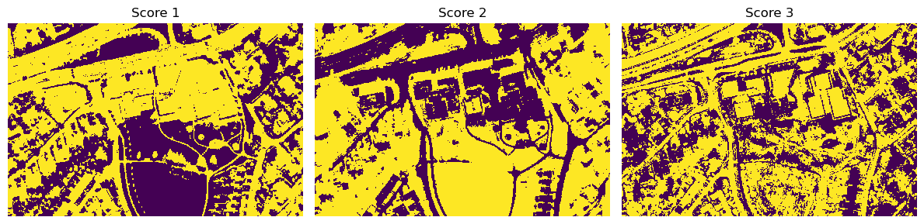

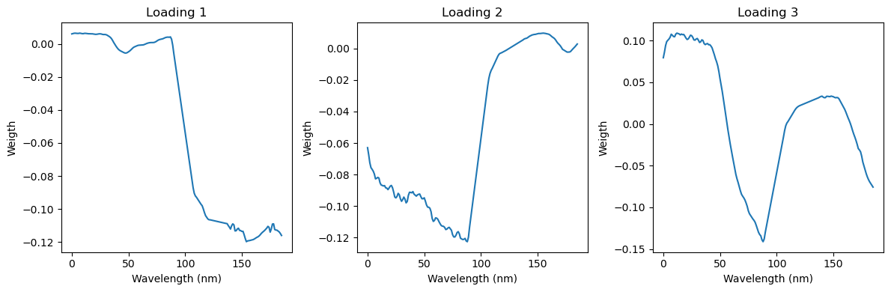

K-Means Clustering
After clustering with both 2, 3, 4 and 5 cluster I would choose the clustering with three clusters. That is, with three there is a distinct separation between areas with vegetation and areas without. With more clusters, it is the non-vegetated areas that are separated in between, inwich are unecessary when you want to separate vegetation and non-vegetation.
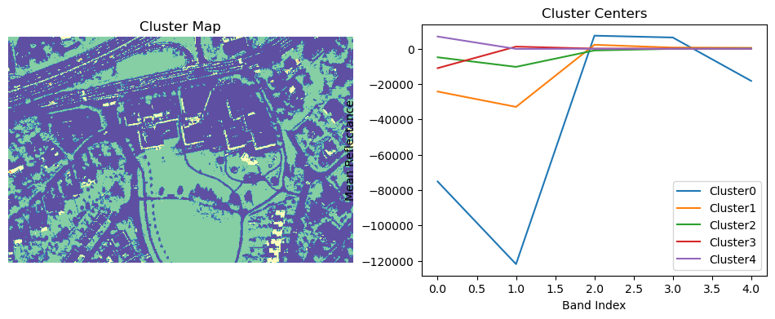
This is the computation of the clustering:

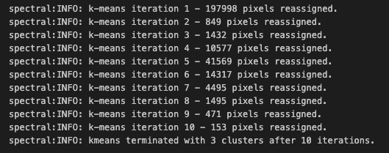

Which method I think is more appropriate?
To determine the amount of vegetation in this hyperspectral image I belive the NDVI method Is most appropriate. That is because it is quick and efficient when leverage the red and NIR spectral bands. It also shows great performance on the image.
With the PCA method I did not manage to separate between the vegetated and non-vegetated areas as I wanted to, and it need further interpretation to function as wanted. The K-Means method works well but is computationally less efficient than the NDVI method. For the purpose of this task it is also a little “over-powered” since it starts separating areas inbetween the vegetated and non-vegetated areas.
s

